**Case 1**

**1.**

In the soft drink industry, Coca-Cola and Pepsi are two dominant brands, each with its unique brand positioning.

**Coca-Cola’s Positioning**

**Target Market**

Coca-Cola primarily targets a broad audience, appealing to all ages. Its marketing revolves around themes of happiness, nostalgia, and universality, positioning itself as a timeless, classic beverage.

**Points-of-Parity**

As a soft drink, Coca-Cola shares several basic attributes with Pepsi, such as being a carbonated, sugary beverage with a similar price range and widespread availability.

**Points-of-Difference**

Coca-Cola differentiates itself through its brand heritage and iconic marketing. Its branding emphasizes tradition, originality, and a unique taste.

**Evaluation**

Coca-Cola’s positioning as a classic brand resonates well with a broad audience. Its emphasis on tradition and original taste has been effective in maintaining a loyal customer base. In an increasingly health conscious market, Coca-Cola might benefit from highlighting healthier options more prominently in its positioning.

**Pepsi’s Positioning**

**Target Market**

Pepsi tends to target younger demographics, focusing on a more youthful, energetic image. Its marketing campaigns are vibrant, aligning with pop culture, music, and sports.

**Points-of-Parity**

Similar to Coca-Cola, Pepsi is a carbonated soft drink with a similar flavor, price, and availability.

**Points-of-Difference**

Pepsi positions itself as a modern brand. It leverages celebrity endorsements and partnerships with music and sports events to have a contemporary image. Pepsi experiments more with flavor variations and product innovations.

**Evaluation**

Pepsi’s focus on a youthful, dynamic image has captured the attention of younger consumers. Its association with pop culture keeps the brand relevant and exciting. Pepsi could strengthen its positioning by addressing health trends, which are important to younger demographics.

**Improving Positioning**

For both Coca-Cola and Pepsi, aligning more closely with current consumer trends towards healthier lifestyles and environmental sustainability could enhance their positioning. They could:

**Expand Healthier Options**

Introducing more low-sugar, low-calorie, or natural ingredient options could appeal to health-conscious consumers.

**Sustainability Initiatives**

Emphasizing efforts in sustainability, such as eco-friendly packaging and responsible sourcing, could strengthen their brand image, especially among environmentally conscious consumers.

**Innovative Marketing**

Both brands could explore innovative marketing strategies that blend their traditional strengths with contemporary issues, like using augmented reality or digital campaigns that highlight community and social responsibility.

Coca-Cola and Pepsi have distinct and successful brand positionings, but focusing on evolving consumer preferences around health could offer avenues for strengthening their market positions. This approach would not only cater to their existing target markets but also attract health conscious consumers.

**2.**

Brand equity is the value a brand adds to a product or service. This value is based on consumer perceptions, associations, and loyalty. Benefits of high brand equity are the ability to charge premium prices, higher customer loyalty, and a stronger competitive position. Brands with high equity are seen as more reliable, of higher quality, and more deserving of trust than brands with lower equity.

**Comparing Brand Equity:**

**Charles Schwab vs. E-Trade**

Charles Schwab has positioned itself as a reliable and trusted brand, offering a wide range of investment services and tools. Its target market includes new and experienced investors looking for comprehensive investment solutions.

E-Trade focuses on being user-friendly and accessible, particularly appealing to younger, tech-savvy investors who prefer online and mobile platforms for trading.

Both brands share points-of-parity like online trading platforms and a range of financial services. However, Charles Schwab’s point-of-difference is in its long-standing reputation and broader range of services, while E-Trade’s is in its user-friendly interface and appeal to a younger demographic.

Both brands have strong brand equity in their respective areas, but they can improve by adapting to market needs, such as incorporating educational resources or sustainable investment options.

**Frederick’s of Hollywood vs. Victoria’s Secret**

Frederick's of Hollywood has been known for its bold and somewhat provocative lingerie. It targets a market looking for more daring and edgy lingerie styles.

Victoria's Secret, on the other hand, has positioned itself as a more mainstream, accessible brand, offering a wide range of lingerie that appeals to a broader audience.

Both cater to the lingerie market, Victoria's Secret's broad appeal and extensive marketing campaigns give it a stronger brand equity. Frederick's of Hollywood could enhance its brand equity by expanding its marketing efforts and possibly broadening its product range to find a more diverse customer base.

**Maytag vs. Kenmore Washing Machines**

Maytag is positioned as a durable and reliable brand, often marketing its washing machines as long-lasting.

Kenmore, is known for its wide range of home appliances, including washing machines that offer functionality at a reasonable price.

Both brands offer quality and reliability, but Maytag’s brand equity is enhanced by its focus on durability as a key differentiator. Kenmore could improve its positioning by emphasizing unique technology features or energy efficiency.

**FedEx vs. USPS Express Mail**

FedEx is known for its quick, reliable, and global shipping services. It appeals to both individual and business customers who need trackable shipping.

USPS Express Mail offers reliable, cost-effective mailing solutions, primarily targeting domestic customers.

FedEx’s global reach and reputation for reliability give it strong brand equity in the shipping market. USPS Express Mail, while strong in domestic services, could enhance its brand equity by expanding and promoting its international shipping capabilities.

In summary, these brands have defined their positioning effectively, but there is always room for improvement, especially in adapting to changing consumer preferences and market trends. Enhancing brand equity involves refining the brand positioning strategy to ensure it stays relevant to its target market.

**3.**

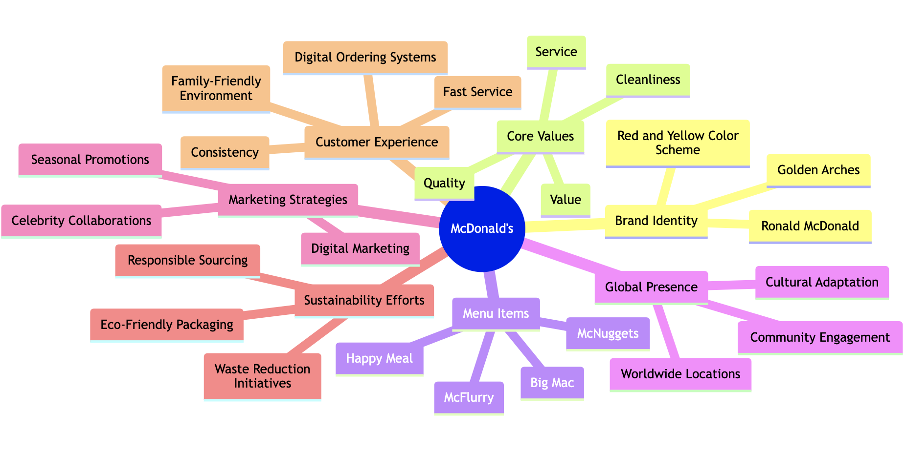

This mindmap captures the essence of McDonald's, a brand that's globally recognized and deeply ingrained in the fast-food industry.

At the core of this map, we have McDonald's brand identity, symbolized by the iconic Golden Arches, the character Ronald McDonald, and their distinctive red and yellow color scheme.

Branching out, we see the core values that McDonald's upholds: Quality, Service, Cleanliness, and Value. These values are not just corporate slogans but are deeply embedded in every aspect of their operations, from menu creation to customer service.

The menu items like the Big Mac, Happy Meal, McNuggets, and McFlurry represent the brand's commitment to offering a diverse range of products that cater to different tastes and preferences.

McDonald's global presence is another significant aspect, highlighting their worldwide locations, cultural adaptation, and community engagement.

Their marketing strategies, including celebrity collaborations and seasonal promotions, showcase their innovative approach to staying relevant and engaging with their audience.

McDonald's also demonstrates a commitment to sustainability through eco-friendly packaging, waste reduction initiatives, and responsible sourcing.

Lastly, the customer experience at McDonald's is characterized by fast service, consistency, a family-friendly environment, and modern digital ordering systems, ensuring that customers have a pleasant and convenient experience every time they visit.

The brand mantra for McDonald's, capturing its core values and attributes, could be summarized as "Quality Service and Consistency in Every Bite." This mantra reflects their commitment to providing high-quality food, exceptional service, and a consistent, enjoyable experience for customers worldwide.